# Lab: Reflection and Attributes

Problems for exercises and homework for the ["CSharp OOP Advanced" course @ SoftUni.](https://softuni.bg/courses/csharp-oop-advanced-high-quality-code)

You can check your solutions here: [Judge](https://judge.softuni.bg/Contests/710/Reflection-and-Attributes-Lab)

# Part I: Reflection

## Stealer

Add the Hacker class from the box below to your project.

|  |
| --- |
| **Hacker.cs** |
| public class Hacker  {  public string username = "securityGod82";  private string password = "mySuperSecretPassw0rd";  public string Password  {  get => this.password;  set => this.password = value;  }  private int Id { get; set; }  public double BankAccountBalance { get; private set; }  public void DownloadAllBankAccountsInTheWorld()  {  }  } |

There is one really nasty hacker but not so wise though. He is trying to steal a big amount of money and transfer it to his own account. The police is after him but they need a proffessional… Correct - this is you!

You have the information that this hacker is keeping some of his info in private fields. Create a new class named **Spy** and add inside a method called - **StealFieldInfo** which receives:

* stirng - name of the class to investigate
* array of string - names of the filds to investigate

After finding the fields you must print on the console:

“Class under investigation: **{nameOfTheClass}**”

On the next lines print info about each field in the current format:

“**{filedName}** = **{fieldValue}**”

Use **StringBuilder** to concatenate the answer**. Don’t change anything in "Hacker" class!**

In your main Method you should be able to check your program with the current piece of code.

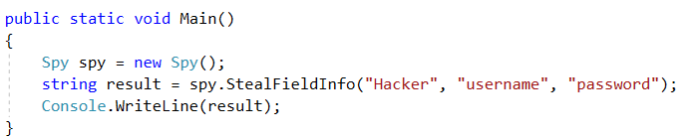

### Example

|  |
| --- |
| **Output** |
| Class under investigation: Hacker  username = securityGod82  password = mySuperSecretPassw0rd |

### Solution

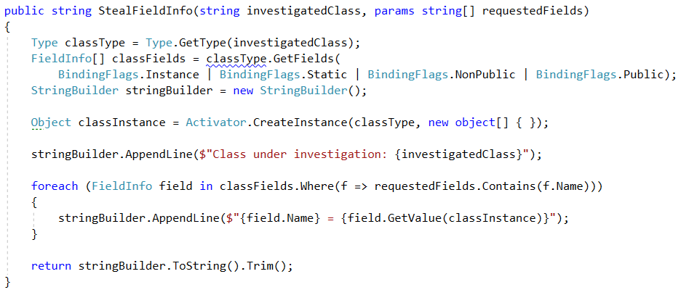

## High Quality Mistakes

You are already expert of **High Quality Code**, so you know what kind of **access modifiers** must be set to members of class. You should have noticed our hacker is not familiar with these concepts.

Create a method inside your Spy class called - AnalyzeAcessModifiers(string className). Check all **fields and methods access modifiers**. Print on console all **mistakes** in format:

* Fields
  + **{fieldName} must be private!**
* Getters
  + **{methodName} have to be public!**
* Setters
  + **{methodName} have to be private!**

Use **StringBuilder** to concatenate the answer**. Don’t change anything in "Hacker" class!**

In your main Method you should be able to check your program with the current piece of code.

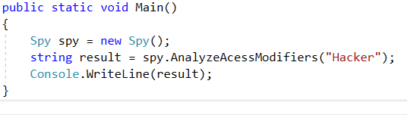

### Example

|  |
| --- |
| **Output** |
| username must be private!  get_Id have to be public!  set_Password have to be private! |

### Solution

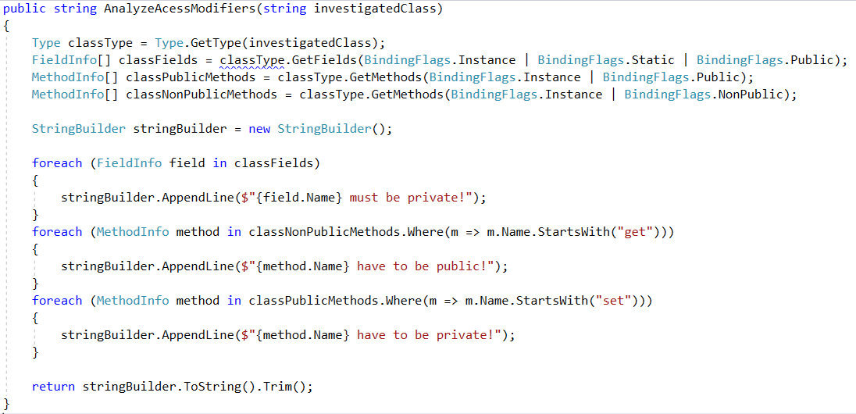

## Mission Private Impossible

It’s time to see what this hacker you are dealing with aims to do. Create a method inside your Spy class called - RevealPrivateMethods(stirng className). Print all private methods in the following format:

All Private Methods of Class: **{className}**  
Base Class: **{baseClassName}**  
On the next lines print found method’s names each on new line  
Use **StringBuilder** to concatenate the answer**. Don’t change anything in "Hacker" class!**  
In your main Method you should be able to check your program with the current piece of code.

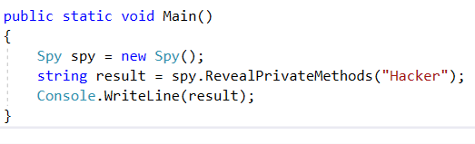

### Example

|  |
| --- |
| **Output** |
| All Private Methods of Class: Hacker  Base Class: Object  get_Id  set_Id  set_BankAccountBalance  Finalize  MemberwiseClone |

### Solution

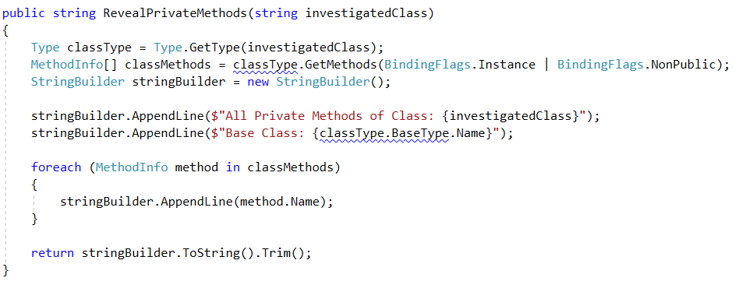

## Collector

Using reflection to get all "Hacker" methods. Then prepare algorithm that will recognize, which methods are getters and setters.

Print to console each getter on new line in format:  
**{name} will return {Return Type}**

Then print all setters in format:  
**{name} will set field of {Parameter Type}**

Use **StringBuilder** to concatenate the answer**. Don’t change anything in "Hacker" class!**

In your main Method you should be able to check your program with the current piece of code.

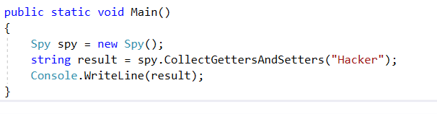

### Example

|  |
| --- |
| **Output** |
| get_Password will return System.String  get_Id will return System.Int32  get_BankAccountBalance will return System.Double  set_Password will set field of System.String  set_Id will set field of System.Int32  set_BankAccountBalance will set field of System.Double |

### Solution

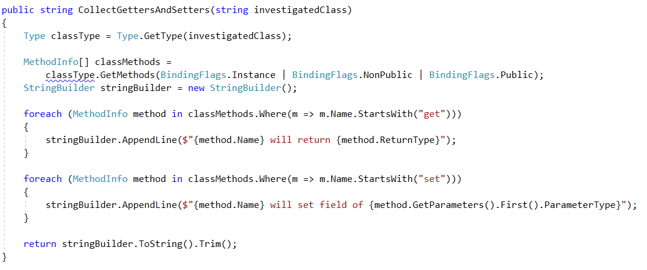

# Part II: Attributes

## Create Attribute

Create attribute SoftUni with a string element called **name**, that**:**

* Can be used over classes and methods
* Allow multiple attributes of same type

### Examples

|  |
| --- |
| StartUp.cs |
| [SoftUni("Ventsi")]  class StartUp  {  [SoftUni("Gosho")]  static void Main(string[] args)  {  }  } |

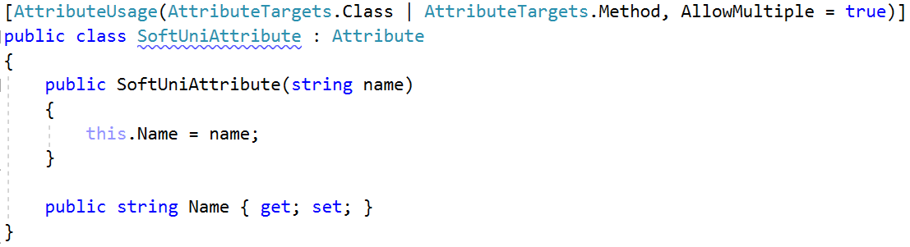

## Coding Tracker

Create a class **Tracker** with a method:

* static void printMethodsByAuthor()

### Examples

|  |
| --- |
| StartUp.cs |
| [SoftUni("Ventsi")]  class StartUp  {  [SoftUni("Gosho")]  static void Main(string[] args)  {  var tracker = new Tracker();  tracker.PrintMethodsByAuthor();  }  } |

